

**ESKİŞEHİR TECHNICAL UNIVERSITY**

**COMPUTER ENGINEERING**

**HOMEWORK I**

**Şevval Hilal YENER 63001244842**

**Ramazan GENÇER 30257416446**

**Aydemir Demirhan DEMİRBAŞ 17276707816**

**BIM 209 PRINCIPLE SOFTWARE AND DESIGN**

**ASST. DR. ZEYNEP BATMAZ**

**SOFTWARE DESIGN**

A passionate kindergarden teacher contacted us about a project. It is about a different way of teaching his students new skill. Recently students are trying to learn how to type on computers using keyboards. Teacher wants to make this process more fun and faster by some kind of fun typing game.

Typing game is a speed typing game that helps in improving the typing speed of players. The aim of the game is to quickly spell the word and get the highest score.

Firstly, the teacher wants to have 3 types of dificulty levels on game which makes game harder by making the words more long and times shorter so it challanges his students more and makes them more ambitious. There must be lots of words. That would be helpful for them to learn new vocabulary too. There must be time limit that shouldnt be exceeded.Lastly player must enter information before starting.Teacher wants to see hes students scores

After entering player info, game wants you to choose difficulty. First word appears and player types the word. If player types correct, player earns points. If player types wrong player loses points.Times run out and saved points showed at screen. Game ends.

**Requirements List**

1. The player enter their information.
2. The player write the word that will appear on the screen.
3. The player’s score will be shown.

**Use Case-I**

1. The player will enter their information and start the game.
2. The player choose one of them game mode that has easy, normal,hard.
3. The word will appear on the screen according to the game mode and the player will be able to stay in the game for the duration of the game mode.
4. The player’s score will be kept and shown.
5. End of the program.

*-Depict (i) clear value, (ii) start and stop conditions, and (iii) external initiator of the use cases.*

**External Initiator:** The player

**Clear Value:** Write the words that appear on the screen and collect points until the time runs out.

**Start Condition:** The player will enter their information and start the game.

**Stop Condition:**  Player’s score will be kept and displayed.

**Use Case-II**

1. The player will enter their information and start the game.
2. The player choose one of them game mode that has easy, normal,hard.
3. The word will appear on the screen according to the game mode and the player will be able to stay in the game for the duration of the game mode.
4. The player’s score will be kept and shown.
5. The player will be able to see the score of other players.
6. End of the program.

*-Depict (i) clear value, (ii) start and stop conditions, and (iii) external initiator of the use cases.*

**External Initiator:** The player

**Clear Value:** Write the words that appear on the screen and collect points until the time runs out.

**Start Condition:** The player will enter their information and start the game.

**Stop Condition:** The player will be able to see the score of other players.

**Use Case-III**

1. The player will enter their information and start the game.

**1.1** The player will be able to start anonymous.

1. The player choose one of them game mode that has easy, normal,hard.

**2.1** If game mode in not selected, the game will start as easy mode.

1. The word will appear on the screen according to the game mode and the player will be able to stay in the game for the duration of the game mode.
2. The player’s score will be kept and shown.

**4.1** Anonymous player’s score will not be kept.

1. The player will be able to see the score of other players.
2. The program ends.

*-Depict (i) clear value, (ii) start and stop conditions, and (iii) external initiator of the use cases.*

**External Initiator:** The player

**Clear Value:** Write the words that appear on the screen and collect points until the time runs out.

**Start Condition:** The player will enter their information and start the game.

**Stop Condition:** The player will be able to see the score of other players.

*-Match steps of use case with the requirements list's items.*

1. The player will enter their information and start the game. **1**

**1.1** The player will be able to start anonymous. **1**

1. The player choose one of them game mode that has easy, normal,hard. **N/A**

**2.1** If game mode in not selected, the game will start as easy mode. **N/A**

1. The word will appear on the screen according to the game mode and the player will be able to stay in the game for the duration of the game mode**. 2**
2. The player’s score will be kept and shown**. 3**

**4.1** Anonymous player’s score will not be kept**. 3**

1. The player will be able to see the score of other players**. 3**
2. The program ends. **N/A**

*-Perform domain analysis (verb and noun analysis).*

1. **The player** will enter their **information** and start **the game.**

**1.1 The player** will be able to start anonymous.

1. **The player** choose one of them **game mode** that has easy, normal,hard.

**2.1** If **game mode** in not selected, the game will start as easy mode.

1. **The word** will appear on the **screen** according to **the game mode** and the player will be able to stay in **the game** for the duration of **the game mode**.
2. The player’s **score** will be kept and shown.

**4.1** Anonymous player’s **score** will not be kept.

1. **The player** will be able to see the score of other **players**.
2. **The program** end.

**Noun Analysis :** The player

Score

Game Mode

Easy Mode

Normal Mode

Hard Mode

**Verb Analysis:** Enter()

Select()

Keep()

Show()

Appear()

*Draw a use case diagram of the system.*

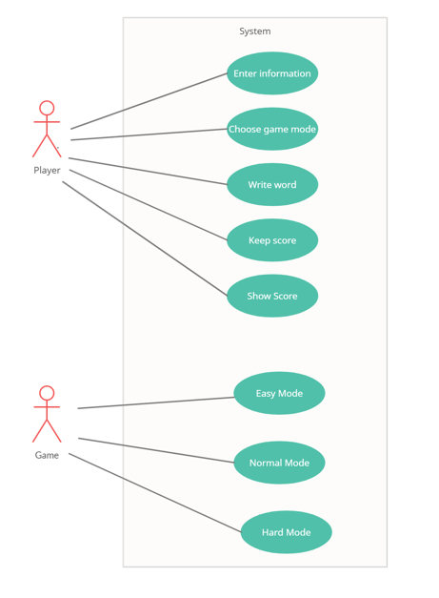

*Make a preliminary UML design and give details about your objects, define relationships between the objects, and apply principles.*

